Metricbeat is used to show the metrics of a web server by using the CLOUD STACK as the Dashboard to view the metrics

Steps to achevie:

1. Create a instance
2. Install apache (sudo apt install apache2 -y)
3. Install Metricbeat on the instance using documentation
4. Configure the metricbeat to cloudstack
5. Enable the apachehttp server log in the elastic cloud
6. Look for the dashboard for the metrics

STEP – 1

CREATE A LINUX INSTANCE IN AWS

STEP-2

INSTALL APACHE2

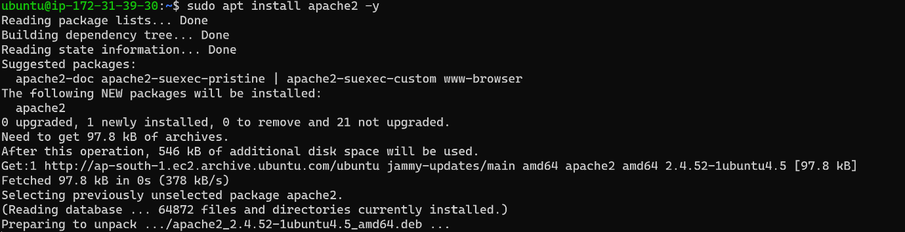

STEP -3

INSTALL THE METRICBEAT ON THE LINUX SERVER

FROM

<https://www.elastic.co/guide/en/beats/metricbeat/8.7/setup-repositories.html#_apt>

STEP -4

CONFIGURE THE METRICBEAT TO CLOUD STACK

The configuration file lies in

Sudo vi /etc/metricbeat/metricbeat.yml

Give the cloud id and cloud auth:

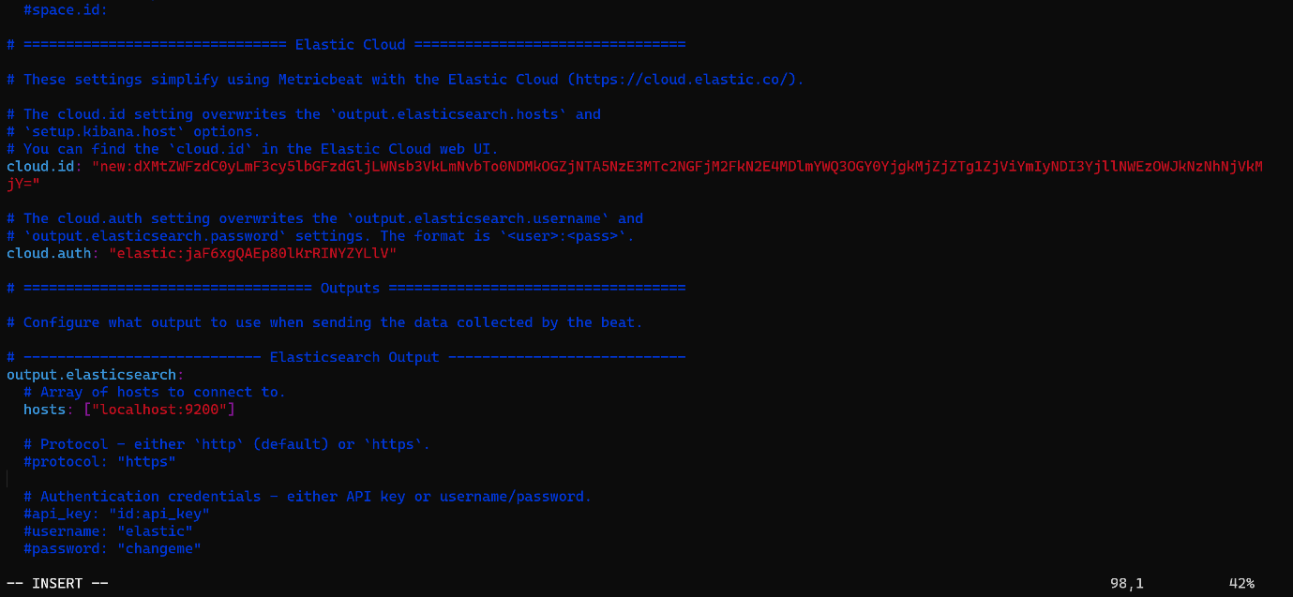

And exit the vi editor

NEXT

Enable the apache.yaml. which is found in the modules

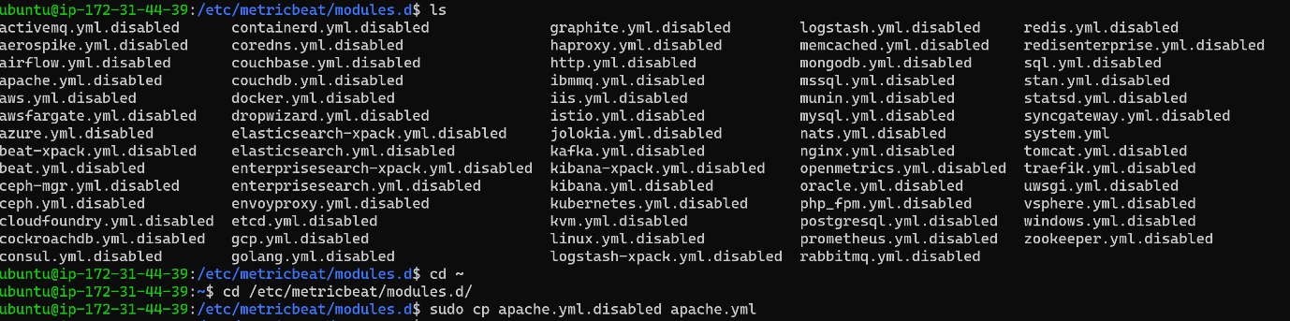

THEN

Cp the file of kibana to the bin folder

sudo cp -r /usr/share/metricbeat/kibana/ /usr/share/metricbeat/bin

and then start the service of metricbeat and apache

sudo systemctl start metricbeat.service

sudo systemctl start apache2.service

STEP -5

Go to the elastic cloud to the dashboard

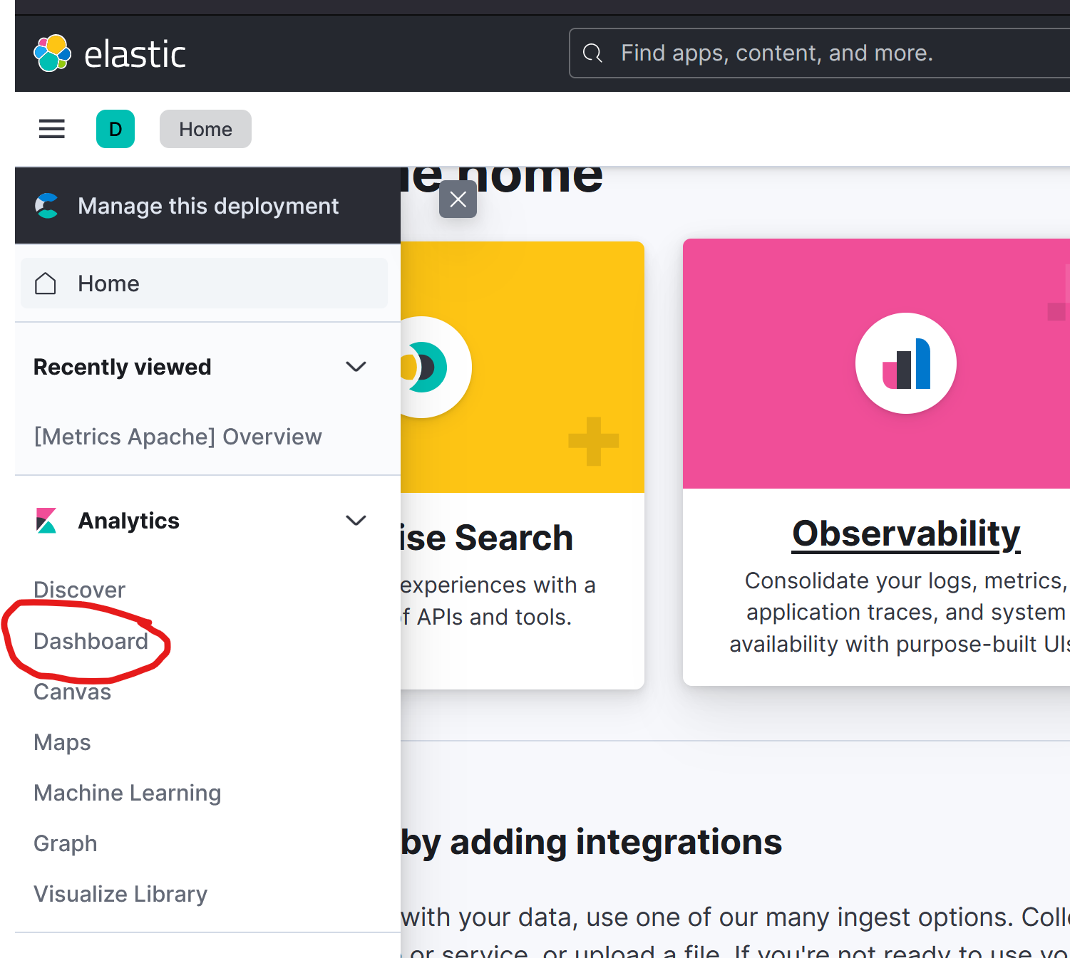

Go to the integration

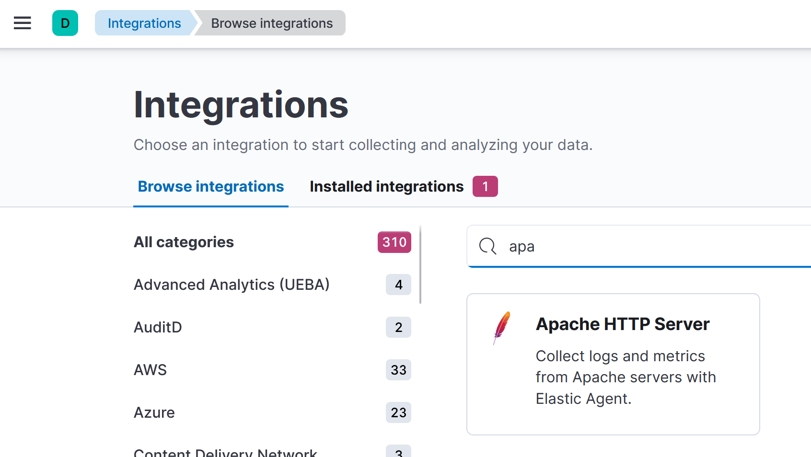

Go to the APACHE HTTP SERVER

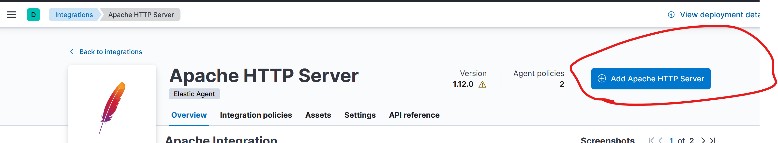

Configure by going to the deb copy the code and paste in the instance

Then

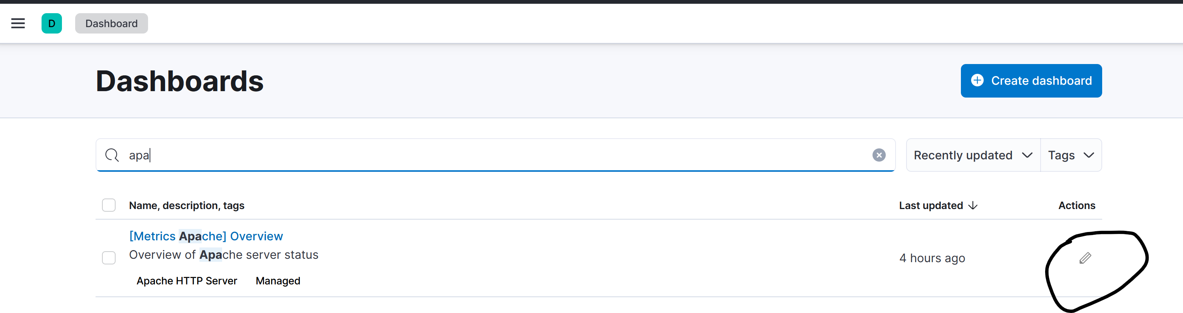

Click under actions to view the dash bord

